**Junior Golf Program for junior boys and girls ages 7 – 17**

**Session 1**: July 6, 13, 20 & 27

Cost: $40.00

***************************************************************************

**Session 2**: August 3, 10, 17 & 24

Cost: $40.00

***************************************************************************

Sign up for both sessions and save $10.00.

Junior Golfers Name: _______________________________ Age: __________

Address: _________________________________________

________________________________________________ Phone: __________________

Please Check: Session 1 Session 2 Both Session 1 & 2

$40

$70

$40

Parental Signature: ______________________________________ Date: __________

Parents and Grandparents are encouraged to volunteer as a coach and mentor for this program. Please check the box below if you are willing to donate your time to a great cause.

YES, I will be a volunteer.

Please stop in to the Elkdale Golf Shop with your registration form and introduce us to your Junior Golfer.

OR Mail registration form with payment to: Elkdale Country Club

P.O. Box 544

Salamanca, New York 14779

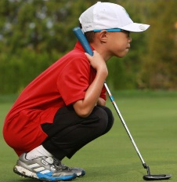

[This Photo](https://www.pnwoptimistclubs.com/2019/04/its-time-for-optimist-junior-golf-in.html) by Unknown Author is licensed under [CC BY-NC](https://creativecommons.org/licenses/by-nc/3.0/)

Attn: Janice Mendell – Junior Clinic

Registration forms and payment must be received by June 15th.

Visit [www.elkdalecc.com](http://www.elkdalecc.com) for program details.